

Department of Electrical & Computer Engineering

*COEN 6711*

*MICROPROCESSOR AND ITS APPLICATIONS.*

Project Report on

**“Automatic Braking System”.**

Submitted to:

Professor. Abdelaziz Trabelsi

**Lord Ganesh Santhar 40010625**

**Kamalpreet Grewal 40010401**

**Mr. Jivanjot Singh Bajaj 40030329**

**Opeyemi Oyedepo 27216386**

**Date Submitted: 02/12/2016**

**Abstract**

The project work presents an ultrasonic automatic braking system for forward collision avoidance with accelerator pedal disengagement mechanism. In our present world, safety has become important aspects of automobile industries. And automation is the key which keep the safety at our fingers. Accidents happen with the automobile vehicles which cause serious injury. One common cause is the failure or inefficient braking system

. An Automobile Braking system is an important innovation to the automobile domain that can assist drivers to brake a car while avoiding imminent obstacle that could cause collision and other fatal condition. The system is based on an ultrasonic emitter and receiver that helps in producing and receiving the ultrasonic waves to determine the distance between car and an obstacle. This can be used to provide some level of safety of cars, in this project, we have design a system that can help stop the automobile by disabling the acceleration and optionally turning away from the direction of the obstacle.

The Sensor will be mounted on the vehicle and the signals are transmitted constantly from it and the reflected signals are received back from the obstacles if any. A Decoder module in the firmware converts the received signals into relative distance between the obstacle and vehicle. A safety Module monitors the calculated distance and if the distance measured crosses above defined safety limit, with the help of a Motor driver which is integrated to of FRDM-KL25Z to drive the vehicle, the FRDM-KL25Z firmware will stop motor driving function and disable acceleration.

The core component and the brain is the Microprocessor Arm Cortex M0+ KL25Z from Arm, which interfaces with other part of the system to provide the desired functionality. Error is also discussed and during the experiment, the improvement for the original system has also achieved.

**Table of Contents**

**List of Figures**

**Introduction:**

The automobiles of today are much more intelligent than it used to be years back. The early automobiles worked based on timing the ignition of the spark using mechanical distributors.

This method of coordinating the timing of the spark delivery when the fuel and air mixture were compressed in the engine cylinders are not efficient enough. Due to the fixed nature of the mechanical setup, it was very difficult to get optimum fuel combustion resulting in the most efficient power output.

Fortunately, the use of real time software in an Automobile have brought about new innovation and features that have several benefits to all stakeholders. An example is the ability of an automobile to adapt to environmental conditions such as air density in order to increase the combustion efficiently subsequently improving fuel economy.

Based on the current fast development in the areas of real time embedded systems, there has been a tremendous increase in the number of intelligent Automobiles, they have become a major tool of transportation in the current society. Automobile safety system becomes perfect as its number soars nowadays.

Because the act of driving requires the high level of coordinations, for example, reversing accidents are very common. This can be minimized if there exist a system that alerts you how far the distance is from obstacles in the reversing vehicle pathway.

Mainly, there are 3 common kinds of system used in the Automobile system for detecting the distance, ultrasonic system, infrared system and radar system. These three systems have strengths and weaknesses.

Ultrasonic systems [2] are widely used in many applications, whose strength lies in its wide range of detection and anti-interference. Moreover, the original material is cheap and production cost is low, making its price more widely acceptable. Its weakness lies in the valid radius of detection that is rather limited and in its accuracy in obstacle detection that is the lowest among the three. Ultrasonic systems are generally used in middle and low-end cars.

The infrared system[3] can have long-distance detection and accuracy outshining that of ultrasonic. However, it’s also plagued by issues like high manufacturing cost and underperformance in detection before mirror obstacles. Therefore, this one is used with the ultrasonic system in high-end cars.

The radar system [4] outperforms the other two. This system outshines the other two in detection radius, range and anti-interference. However, its high manufacturing cost is not preferred by manufacturers of home-use and commercial automobiles. This type of system is generally used in military vehicles. original ultrasonic reversing warning system[5] is more like a safety distance alarm system, it is used for monitor a distance between the source car and obstacle, if the distance is less than the safety distance, it will activate an alarm to alert the driver.

For our project , the Automatic braking system is based on the Ultrasonic systems . The main target of the ultrasonic braking system is that, cars should automatically brake when the sensors sense the obstacle.

**Aim and Objectives.**

The aim of this project is to implement an Automatic Braking system based on the Arm cortex m0+ FRDM-KL25Z, as the core of the system, this microcontroller will receive a signal about an obstacle detected by an ultrasonic Sensor and stop motor driving function and disable acceleration through the integrated motor Driver IC. Specific objective in the project includes.

1. To Explore in detailed all the functionality of the m0+
2. Understanding of the interfacing of Arm cortex with other important component
3. System integration of Arm cortex m0+
4. Complete system prototyping
5. To develop a safety car braking system using ultrasonic sensor
6. Final report, Demo of the working prototype
7. To design a vehicle with less human attention to the driving

**Motivation**

The use of various types of automobile has become an integral part of human activity. The movement of people from one location to another is a typical scenario of the daily use of automobile. Thus the number of automobiles is increasing day by day. However, some uncertain and unpredictable situations such as accidents do occur from time to time in an increasing manner. Accidents do occur every time and everywhere and can result into severe damages, serious injury and even death. These accidents are usually cause by several factors but of important is the influence caused by delay of the driver to hit the brake or a failure in the part of the braking system. This project is designed to develop a new system that can solve this problem where drivers may not brake manually but the vehicles can stop automatically when detecting obstacles.

Presently, cars have the alarm system where when the car gets too close to an object an alarm is triggered which warns the driver about an object close by. But this feature has produced lot of problems and is prone to human error. This project will enhanced the feature by using similar sensors but with the advantage that we have a mechanism that the car brakes automatically when an obstacle is close.

This project is about a system that can control braking system for safety. Using ultrasonic as a ranging sensor, its function based on ultrasonic wave. After transmitting by transmitter, the wave can reflect when obstacle is detected and then received by receiver. The braking circuit’s function is to slow down or stop the car automatically after receiving signal from the sensor

**Scope of Project**

**This project focus on the implementation of an** ultrasonic automatic braking system for forward collision avoidance with accelerator pedal disengagement mechanism. The Arm cortex M0+ is the core of the system design and interfacing with other important component such as the sensor, Motor IC and others. Thus the project will aim at developing an ultrasonic sensor to detect the obstacle. Furthermore, the output from the ultrasonic sensor is used to drive the motor as an actuator.

**Review of literatures on Braking systems // will compress this to let say One page or so**

The Reverse Alert System was first developed by Surveillance Guard Corporation (SVG). It was the world first aftermarket automatic braking system that can be fitted to any vehicle. This system firstly fitted in Australian vehicles and has been taken extensively trialed across the passenger vehicle market, road transportation and taxi industries. This system begins with ultrasonic sensors that were fitted at rear of the vehicle. These sensors detect an object at 1.6m a signal is sent to a solenoid located at the front of the vehicle. The solenoid is attached to a flexible cable that runs through the firewall and is attached to a universal brake pedal clamp that is fitted on the brake pedal. Subsequently, when the solenoid is activated this pulls the brake pedal -stopping the vehicle automatically.

The Reverse Alert Technology was installed on following vehicles: [7]

* Two Ford Ranger Light Commercial Vehicles (1 x 1.6m and 1 x 2.5m systems) and;
* Two Hino Trucks (both equipped with the 1.6m system) – EWP and Line Truck.

ABS (Anti-lock Braking System) which helps the rider gets a hassle free braking experience in muddy and watery surfaces. [4] It applies a distributed braking and prevents skidding and wheel locking. In 1988 BMW sold for the first time electronic-hydraulic motorcycles. The first Japanese maker selling motorcycles with ABS was Honda ST1100 equipped optionally with electro-hydraulic ABS module in 1992. [9]

With the ABS, if the rider only brakes with the front or rear wheel, the braked wheels tends to lock up faster as if both brakes would have been applied. A [Combined Braking System](http://en.wikipedia.org/wiki/Combined_braking_system) (CBS) distributes the brake force also to the non-braked wheel to lower the possibility of a lock up, increase deceleration and reduce [suspension](http://en.wikipedia.org/wiki/Suspension_(motorcycle)) pitch. [10]

Volvo is all set to launch its new XC60 SUV which will sport laser assisted braking which will be capable to sense a collision up to 50 mph and apply brakes automatically. [1]

Working Principles of Brake System

Current brake systems fall into two types: drum brakes and disk brake [13]. Both have

distinctive strengths and weaknesses.

Drum brake:

Drum brake has been used in automobiles for a long time. Its reliability and excellent braking performance have accounted for the popularity today. In drum brake, two semi-circular brake pads are inserted onto the inner wheel ring and slow or stop the car via friction between pads and wheels following the principle of leverage theory. Drum brake is mostly applied to big-tonnage cars (and mostly used in the rear wheels). Here’s the working principle: with two semi-circular brake pads in the inner ring of wheels, The drive stomps on the brake, hydraulic piston rods connected to the brake pad will put the motionless pads in contact with wheels in speedy motion and create a tremendous amount of friction force, Thus reducing wheels’ rotation speed or stopping the car. Its strengths include great force of braking force and the function of automatic tightening-braking. The processing and composition of parts are relatively simple and easy to handle. Another strength is its low production cost. Its weaknesses: in the case of successive brake, the pads will be overheated by the inner wheel ring and heat-fade if such case lasts long. This will compromise the brake effect. It’s also plagued by slow response of the brake system and not suitable for highfrequency braking actions. The large number of parts in drum brake system makes it a big trouble to debut and maintain the brake system.

Disk brake:

As the disk brake has its pads exposed to air in the outer ring of the wheel, heat can be well dissipated and pads won’t heat-fade with successive braking actions. So, the disk brake has a

higher level of safety and becomes the major trend (mostly used in front-wheel-driven cars).

Many disk brakes also have ABS(Anti-lock Braking System)[14] to improve its level of safety ( refers to that an air sac inside the valve body, creates friction between the wheel and

brake pad owing to its instant pressure on brake oil. The air sac then retracts and continues to

apply pressure on the brake oil. The process will go on and on. Each second may see 8-30

Hai Wang & Ronghong Xiao Automatic Car Braking System 18 occurrences of such process. This system can prevent instant wheel locking in braking and cars sideslipping or turning over caused by inertia.) Disk brake works via two brake pads located on both sides of a wheel. When the driver stomps on the brake, two pads will get closer, clamp the moving wheels and apply friction to stall the car. Strengths of this brake system include: its dissipation effect is better than that of the drum brake; in the case of successive brakes, there won’t be heat-fading; it lasts long; brake response speed is fast and suitable for high-frequency braking cases. The structure of the disk brake system is easier than that of the drum disk, thus facilitating debugging and maintenance. The weaknesses of

the disk brake include: its braking force isn’t as strong as that of the drum brake; it’s hard to

mount a disk brake; moreover, the cost of disk brake is higher than that of drum brake.

**3.0 System Overview:**

**System Block Diagram:**

Microprocessor FRDM KL25Z

HC-SR04 Sensor

Robot Car Chassis kit

Motor Driver IC - L293DNE

Blue tooth

Mobile App

**TOOLS AND BUDGET**

**Hardware Tools Purchased:** *Total Budget - 340 CAD*

|  |  |  |
| --- | --- | --- |
| **QUANTITY** | **DESCRIPTION** | **TOTAL AMOUNT** |
| 1 | FRDM KL25Z | $25 |
| 1 | HC-SR04 Sensor | $21.4 |
| 2 | Robot Car Chassis kit | $49 and $127 |
| 1 | Motor Driver - L293DNE | $53.93 |
| 1 | HC-06, 3.6V - 6V Bluetooth Module | $5.3 |
| 30 | MALE TO MALE CONNECTORS | $10.73 |
| 30 | MALE TO FEMALE CONNECTORS | $13.43 |
| 3 | BREADBOARD | $17.94 |
| 1 | Finger BATTERY | 20$ |
| 50 | Wires |  |
| 2 | Resistors |  |
| 1 | Power Bank |  |

**Functional description/methodology**

This Project utilizes Ultrasonic Sensor to detect the distance of obstacles from vehicle and based on the input from sensor, the firmware of FRDM-KL25Z brakes the vehicle if the obstacle is too close to the vehicle. It also contains a Motor driver which is integrated to of FRDM-KL25Z to drive the vehicle. The Sensor will be mounted on the vehicle and the signals are transmitted constantly from it and the reflected signals are received back from the obstacles if any. A Decoder module in the firmware converts the received signals into relative distance between the obstacle and vehicle. A safety Module monitors the calculated distance and if the distance measured crosses above defined safety limit, it interrupts FRDM-KL25Z firmware to stop motor driving function and disable acceleration**.**



**Procedures**

Some of the important activities of our implementation includes the understanding of functional behavior of the component and how they are to interface with our Microcontrollers. A lot of activities were carried out in relation to testing to ensure that we are able to achieve the implementation.

Testing is a disciplined process that consists of evaluating the application (including its components) behavior, performance, and robustness -- usually against expected criteria. Expected behavior, performance, and robustness should therefore be both formally described and measurable. Verification and Validation (V&V) activities focus on both the quality of the software/Hardware product and of the engineering process. Testing is most often regarded as a detective measure of quality, it is closely related to corrective measures such as debugging. In practice, embedded system engineers usually find it more productive to enact testing and debugging together, usually as an interactive process. Debugging literally means removing defects ("bugs").”

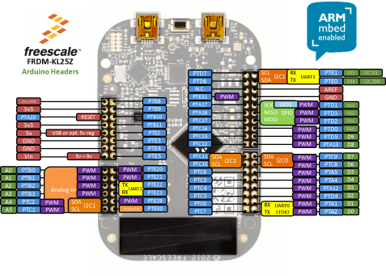**Brief Description of the tools:**

* FRDM KL25Z Processor:

The Freedom KL25Z is an ultra-low-cost development platform built on ARM® Cortex®-M0+ processor.it has very easy access to MCU I/O, battery-ready, low-power operation, a standard-based form factor with expansion board options and a built-in debug interface for flash programming and run-contro

Features of the Freescale Kinetis MKL25Z128VLK4 Processor:-

* MKL25Z128VLK4 MCU – 48 MHz, 128 KB flash, 16 KB SRAM, USB OTG (FS), 80LQFP
* Capacitive touch “slider,” MMA8451Q accelerometer, tri-color LED
* Easy access to MCU I/O
* Sophisticated OpenSDA debug interface
* Mass storage device flash programming interface (default) – no tool installation required to evaluate demo apps
* P&E Multilink interface provides run-control debugging and compatibility with IDE tools
* Open-source data logging application provides an example for customer, partner and enthusiast development on the OpenSDA circuit
* mbed enabled
* HC-SR04 Sensor:

The HC-SR04 Distance Measuring Sensor is an inexpensive, short range ultrasonic sensor.

Ultrasonic ranging module HC - SR04 provides 2cm - 400cm non-contact measurement function, the ranging accuracy can reach to 3mm. The modules includes ultrasonic transmitters, receiver and control circuit. The basic principle of work:

(1) Using IO trigger for at least 10us high level signal,

(2) The Module automatically sends eight 40 kHz and detect whether there is a pulse signal back.

(3) IF the signal back, through high level , time of high output IO duration is the time from sending ultrasonic to returning. Test distance = (high level time×velocity of sound (340M/S) / 2,

**Specifications:**

* Working Voltage : 5V(DC)
* Static current: Less than 2mA.
* Output signal: Electric frequency signal, high level 5V, low level 0V.
* Sensor angle: Not more than 15 degrees.
* Detection distance: 2cm-450cm.
* High precision: Up to 0.3cm
* Input trigger signal: 10us TTL impulse
* Echo signal : output TTL PWL signal

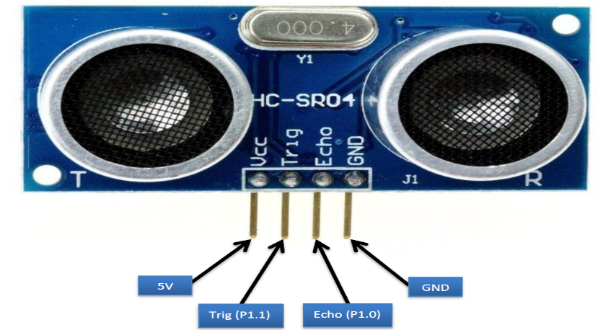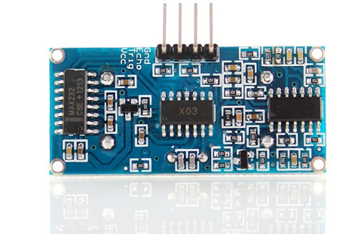

* Robot Car Chassis kit:

Functions and Features of the Car Chassis kit:-

This Magician chassis is a versatile robot platform featuring two gearmotors with 65mm wheels and a rear caster for differential movements. The chassis plates are cut from acrylic with a wide variety of mounting holes for sensors, controllers, power, etc. Simply bolt the two pre-cut platforms together, attach the motors and caster and add your favorite robotics controller. This kit includes all of the parts needed to assemble the chassis as well as a 4xAA battery holder with barrel jack termination. Note: The chassis requires assembly but has detailed instructions.

Smart car chassis tracing car Robot car chassis with code disk

Ideal for DIY

Mechanical structure is simple, it is easy to install

This car is the tachometer encoder

With a 4 AA battery box (batteries not included)

Can be used for distance measurement, velocity

Can use with other devices to realize function of tracing, obstacle avoidance, distance testing, speed testing, wireless remote control

Size: 20 x 14cm (L x W)

Wheel size: 6.5 x 2.7cm (Dia. x H)

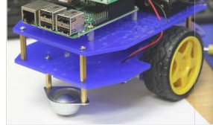

Motor Driver - L293DNE

Following are the features of the L293DNE:-

This IC Run four solenoids, two DC motors or one bi-polar or uni-polar stepper with up to 600mA per channel using the L293D

* Wide Supply-Voltage Range: **4.5 V to 36 V**.
* Separate Input-Logic Supply.
* Internal ESD Protection.
* Thermal Shutdown.
* High-Noise-Immunity Inputs.
* Output Current 1 A Per Channel (**600 mA for L293D**).
* Peak Output Current 2 A Per Channel (**1.2 A for L293D**).
* Output Clamp Diodes for Inductive Transient Suppression (L293D).

**Applications of L293D Dual H- Bridge Motor Driver IC:**

* High Current Motor Driver IC.
* Dual H-bridge for controlling up to two motors at a time.
* Ideal for Inductive load de coupling from the main/control unit.
* Wide voltage range allows for an adaptive voltage range control.

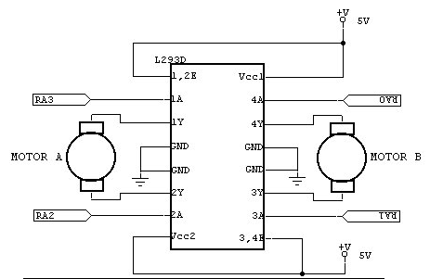

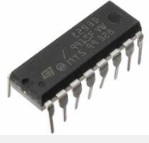

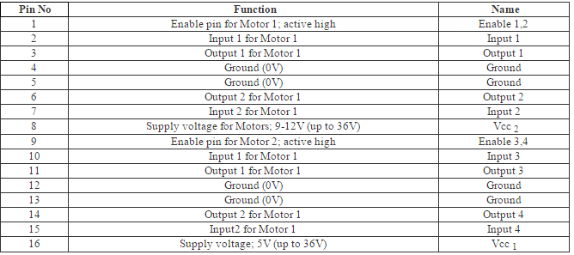

* **Bluetooth Module** :

#### HC-06, 3.6V - 6V Bluetooth Module -

Operates from 3.6v to 6v, which means you can use interface this simple device to any micro controllers.  The added simplicity of the four pre-soldered connectors results in a very easy n' quick plug and play for any future projects. This device can work up to 10 meters, the voltage supplied must not exceed 6v and it is not reverse polarity protected. Comes preheat-shrink with clear coating to protect the device from anti static discharge, dust protection and accidental shortage while maintaining an elegant look. Use this 3.6cm x 1.5cm device for any project you may have in mind and rest assure with this Bluetooth based device will consume less power than a traditional WiFi Module! No Firmware = No Fuss, pairing code 1234 (default) and Logic Levels of RX & TX are 3.3V.

Main features of the Keypad are listed below:

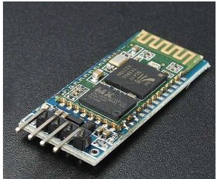

**Software Tools**

For the software, we used MBED online compiler.

Benefits of using MBED Compiler:

* USB drag and drop programming interface
* Entry-level online Compiler
* High-level peripheral abstraction
* Easy to use C/C++ SDK
* Lots of published libraries and projects

**Roles and responsibilities: // do you want this as part of the report**

**Total # of Hours spent on the project:** Along with 4 hours of lab session per week coming up to 32 hours for two months, extra 3 hours per day i.e., up to 180 hours for 2 months with additional hours over the weekend, We as a team spent approximately 220 hours for research, implementation, coding, testing, documentation etc.

**POST MORTEM ANALYSIS:** During the initial days of the project the team members researched about the project, studied the pin configurations, learnt about coding on mbed, learnt about the drivers needed which was a good progress. Second stage involved the hardware connections and we were successful in making the LCD say “HELLO”. Then our FPS, which was very challenging as not sufficient resources were gathered to implement the module which led to the damaging of the module. This point gave us a big hit as our project was on hold for a while and also we wasted a lot of time on debugging without thinking about the broken circuit of FPS. So if we had spent enough time on the configurations and working of FPS then we would have overcome this problem, which needs to be taken care in future. GSM was challenging too but did not affect majorly as FPS. Since some more time is required to implement GSM this could be considered as our future work.

**Flow Chart:**

Start

Input from sensor

Compare with stored finger print

Valid user?

u

Send code to the user mobile

Ask for code

Valid user?

Open the locker

Stop

**Schematics.**

**Results and Discussion:**

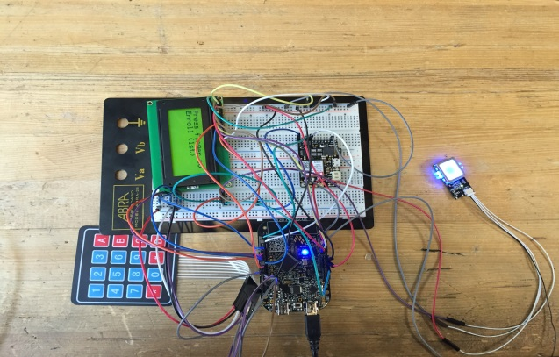**Hardware Implementation: // needs kamal inputs**

**///interfacing description.**

Fingerprint sensor, GSM module, Keypad and LCD are connected to FRDM KL25Z processor. All the digital pins of LCD are connected to digital pins of the FRDM KL25Z processor. Transmitter pin of fingerprint sensor and GSM module is connected to UART receiver pin of the processor. Receiver pin of both the components is connected to UART transmitter pin of the FRDM KL25Z. All pins of the keypad are connected to digital pins of the processor. FPS, LCD display and Keypad act as user system. Fingerprints are already stored in the database of the FPS. Every time we give fingerprint as input comparison takes place with the stored fingerprints. After LCD displays valid user, a code is sent to the authorized user’s mobile number through GSM. User gets the access to the safe only after entering the valid code received from the GSM.

During the project implementation, first thing we realized was that working with fingerprint sensor and GSM module was quite challenging. As GSM itself is a project on its own and implementing in our project increased the complexity of our application. But with the positive attitude and hard work we completed the project on time.

As a team if we had researched enough on the project, components used and the software we would have been able to complete our implementation with ease and in a more efficient way.

**simulations /// needs Ganeshs input**

**Software implementation --// RTOS, threads, functions**

**Testing**

In our project we performed:

* Unit Testing: where we ensure that the individual parts are working correctly.
* Functional Testing: where the testing of the functions of component or system was done and the question “Can the user perform this “ was answered.
* Regression Testing: was to verify that modifications in the software or the environment have not caused any unintended adverse side effects and that the system still meets its requirements.

Hardware Testing involved testing of individual components by making use of the IEEE Labs:

* Processor: tested if it drew or delivered enough Voltage, Current, Power.
* Sensor: Connected the Ground and Vcc to the Oscilloscope and observed if a square wave was generated when the fingerprint was given as an input.
* LCD: tested and Verified the digital pins and the connections.

Developing simple Test cases/runs/plans helped in the Software testing which was further enhanced to perform Hardware Testing.

Bugs Found in Hardware Testing:

* Due to the misconnection of the sensor to the FRDM board, which further damaged the sensor circuit led to the Malfunctioning of the sensor leading to incorrect results. Bug reported when the sensor chip was getting overheated very quickly. Bug Fixed by replacing with a new sensor.
* Missed on testing the compatibility of the components which led to a lot of challenges and was overcome by replacing or by following an alternate method.

Bugs Found in Software Testing:

* Incorrect libraries imported on mbed led to the compilation failure. Bug fixed by importing/updating the right libraries and by modifying the code.
* Errors while declaring the functions leading to major exceptions caused the program to fail. Attention to detail fixed the bugs.
* Failed to install the PED Drivers led to the unrecognition of the COM ports on the system which held up the project for a while, as we were unable to test the program and the working of the sensor using the SDK_DEMO test Software which needed the details of the COM ports. Installation of the necessary drivers made the work easy.

**Methodology**

**Process flow—software development cycle.**

Our implementation is capable of providing the 2 levels of highest security. First level using biometrics where the user would be given access to the bank locker only when the fingerprint matches. Second using the GSM Technology where the valid user receives an OTP which he needs to enter using the keypad to access the bank locker. The system has a LCD which displays the instructions and all the results.

We have been able to implement the first level of security by using the fingerprint sensor GT511C3, FRDM KL25Z and LCD TC1 604A-01 with at least 5 fingerprints stored. The high performance, low power, robust system cost efficient, real time, Quick response time, fully automated system application provides high security with maximum efficiency.

We were able to work on the hardware and software part of the second level of our project i.e., using GSM Technology. Hardware involved the configuration of keypad and GSM Module SIM800L .But our project was on hold for few days as the fingerprint module was damaged and needed a replacement. Once that was fixed we rescheduled our work on GSM, however the entire implementation might need some attention on the connections and the code for which we would require maximum a week or two to complete the second important objective of our project. Hence it can be considered as our Future work.

**Project Schedule**

The below table shows the proposed schedule that is being used to achieve the deliverables required for our automatic braking system. All major tasks were loaded and shared among the group members and are completed timely as planned.

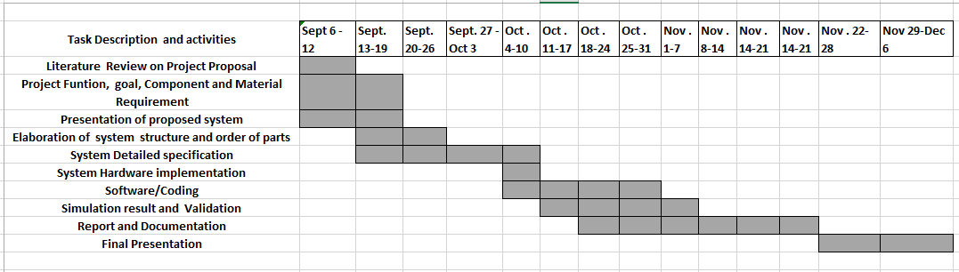

**Project Diary**

As a requirement for the project, we decided to use a collaborative and tracking technique too so that we can easily monitor and manage the progress we were making on our project at a specific time. We are using the Github open source as our collaborative tool that gives each and every member an opportunity to update on the deliverables in a flexible manner. It was really very helpful in achieving our goals**.**

[**https://github.com/gsanthar/Automatic-Braking-System**](https://github.com/gsanthar/Automatic-Braking-System)

**Conclusion**

1. If we can reduce the driver’s interference in braking and give the responsibility to a smart sensor which will take decision and initiates the response to measure the distance from an obstacle and also senses it for a predefined time period. Further, if distance of impact is closing it will apply brake automatically and stop the vehicle in advance.

2. Moreover distractions while driving is a major contributor to accidental deaths, thus by implementing this system we can reduce the close impact potential accidents.

3. By dragging the front seat in opposite direction to impact and increase the distance and time of direct impact the deaths can be minimized and safety of vehicle can also be improved, and also it can add the new feature to the car which will attract the customers

4. The results of the simulation showed that by using an energy absorbing seating system, crash deceleration can be effectively attenuated and occupant injuries significantly reduced in comparison to conventional seating systems. In future, physical crash tests will still be required as the final certification method for approval of a particular crashworthy mechanical system. However during the development process the application of computer simulation methods as presented in this paper show that it is possible to reduce development costs.

**REFERENCES:**

1. <http://www.ibm.com/developerworks/rational/library/459.html>
2. <http://www.farnell.com/datasheets/1651277.pdf>
3. <https://mcuoneclipse.com/2013/01/01/tutorial-ultrasonic-ranging-with-the-freedom-board/>
4. <http://www.rakeshmondal.info/L293D-Motor-Driver>
5. <http://www.micropik.com/PDF/HCSR04.pdf>
6. <http://www.ti.com/lit/ds/symlink/l293.pdf>

Appendix// need get some code from our mbed for this.

**Implementation and Testing:**

**PSEUDO CODE:**

#include "mbed.h"

#include "GT511C3.hpp"

#include "TextLCD.h"

Serial debug(USBTX,USBRX);

TextLCD lcd(PTE20,PTE21,PTE22,PTE23,PTE29,PTE30,TextLCD::LCD16x2);

DigitalOut myled(LED1);

GT511C3 finger(PTE0,PTE1);

int progress(int status,char *msg)

{

debug.printf("%s",msg);

return 0;

}

int main() {

int sts = 0;

//int ID = 0;

debug.format(8,Serial::None,1);

debug.baud(115200);

debug.printf("Fingerprint reader module \"GT-511C3 / GT-511C31\" test program.\n");

debug.printf("Build: %s %s\n",__DATE__,__TIME__);

debug.printf("Open\n");

sts = finger.Open();

lcd.printf("sts = %d\n",sts);

lcd.cls();

wait(0.001);

sts=0;

lcd.printf("value sts= : %d \n", sts);

lcd.printf("Hello World");

lcd.locate(0,1);

lcd.printf("It Works!");

}

if(sts == 0)

{

int i;

lcd.printf("FirmwareVersion = %lx\n",finger.FirmwareVersion);

lcd.printf("IsoAreaMaxSize = %ld\n",finger.IsoAreaMaxSize);

debug.printf("DeviceSerialNumber = ");

for(i = 0; i < sizeof(finger.DeviceSerialNumber);i++){

debug.printf("%02X",finger.DeviceSerialNumber[i]);

debug.printf("\n");

}

}

if(1){

int EnrollID = 11;

if(finger.CheckEnrolled(EnrollID) == 0){

lcd.printf("EnrollID(%d) is already enrolled.Delete!\n",EnrollID);

if(finger.DeleteID(EnrollID) == 0){

debug.printf("Delete OK!\n");

}

finger.CmosLed(1)

while(1){

debug.printf("Press finger for Identify\n");

finger.WaitPress(1);

if(finger.Capture(1) != 0)

continue

ID = finger.Identify();

lcd.printf("ID = %d\n",ID);

debug.printf("Remove finger\n");

finger.WaitPress(0);

}

}